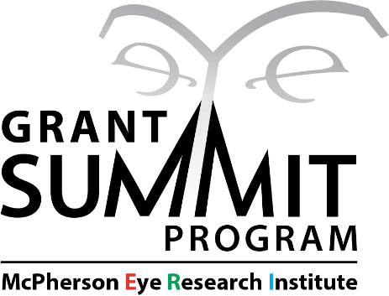

Purpose/rationale: The Grant Summit Program (GSP) was created to increase support for UW–Madison vision research by facilitating successful resubmissions of competitive federal grant applications. To this end, the program provides McPherson ERI investigators up to $10,000 over the course of a year to help them to further develop their grant applications and gather additional data to support resubmission. Examples of supportable activities include, but are not limited to, lab personnel salary (not PI salary), grant writing expertise/review, as well as costs to complete experiments, obtain equipment/tools, add research subjects, etc.

Funding is available for use only over a one-year period: Thereafter, any unused funds will be returned to the McPherson ERI. All GSP award recipients must agree to resubmit their grant applications within one year of receiving their award.

Eligibility Requirements and conditions on award use:
To be eligible to apply for GSP funding, you must…
.
- …be a McPherson ERI member at UW-Madison engaged in vision-research.

- …be faculty or a permanent principal investigator.

- …be applying to resubmit a federal grant (must provide indirects) that has been deemed competitive by the study section as determined either by receiving a percentile score (NIH) or a ranking other than “noncompetitive” (NSF). Only scored applications will be considered.

- ...be requesting no more than the allowable $10,000 maximum

If awarded GSP funding, you must…

- …expend all GSP award funds within one year of the date that you receive them. Funds remaining one year after issuance of the award will be retained by the Institute.

- …agree to resubmit your grant within one year of the date that you receive your GSP award funds (delay in resubmission past one year without approval may result in future GSP applications being ineligible).

- …present data obtained with support from your GSP award within 1–2 years at a McPherson ERI-sponsored event (e.g., our monthly seminar series or MERI-At-A-Glance).

- …acknowledge McPherson ERI GSP funding on presentations and/or publications supported by your award. You can find out how to acknowledge MERI awards by clicking here.

The applicant is welcome to discuss her or his proposal with McPherson ERI administration and staff prior to application, but this is not a requirement. For any questions on award eligibility or conditions on award use, contact Dr. Jonathan Lang at jonathanlang@wisc.edu.

Proposal review: GSP proposals will be reviewed by an ad hoc committee comprised of McPherson ERI members with appropriate subject area knowledge. Funding decisions be made on a rolling basis with no internal deadlines or pre-determined grant quotas.

Application format: To apply for a Grant Summit Program Award you will need to...
- Complete the application on the provided fillable form using single-spaced text and Arial font no smaller than 11 point. The form will require that you provide:
  - a brief explanation of how the funding will improve the revised proposal (500 words or less).
  - a brief comment on the proximity of the applicant’s grant score to historical pay-lines and/or other insights regarding the likelihood of successful resubmission (1-3 sentences).
  - a targeted, fit-for-purpose budget request (up to $10,000) along with a brief explanation of how the requested funding will improve the revised proposal (500 words or less).
  - your signature as PI
- Attach your grant score/summary sheet to the end of your application form.

Submission deadline: None. Submissions are accepted for this program year-round.

All materials should be saved as a single PDF and submitted to Dr. Jonathan Lang (jonathanlang@wisc.edu). When submitting, format your email subject line as follows:

GSP Award Application: [your last name], [your first name]

Applicant Name:
UW–Madison Department:
Applicant Email:
Applicant Phone:
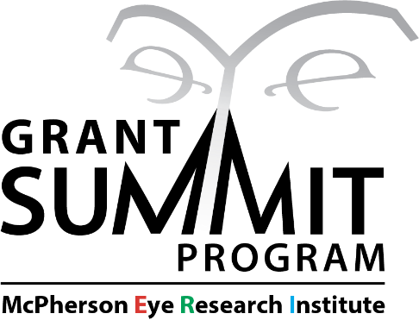

Federal Granting Agency and Study Section:
Co-Principal Investigator Name(s):
Project Title:

Brief explanation of how requested funding will improve the revised proposal (500 words or fewer):

Brief comment on proximity of applicant’s grant score to historical pay-lines and/or other insights regarding the likelihood of successful resubmission (1 – 3 sentences):

Brief budget statement (500 words or fewer): How will funds be used for this resubmission?

Please list all key collaborators on this grant (if any) and their role

Have portions of this project been funded by other MERI awards (awards either to trainees or to the PI’s laboratory)? Note: Having portions of your project funded by other MERI awards is allowed unless there is overlap in specific expenses.

Yes
No

If you answered ‘YES’ to the question above, list the award(s), the year received, and briefly describe how the aspects of the project funded by the previous award(s) are different from those of the current project proposal.

Signature of Applicant:______________________________________________________________

Checklist:
Completed application signed by principal investigator
Copy of grant score/summary sheet

