UW Virtual Brain Project

Oculus Go Virtual Reality Headset MH-A64

The UW Virtual Brian Project™ is making education more engaging through virtual reality (VR). The immersive learning environments spark excitement and improve students’ understanding of how the brain works.
General Overview:
The Virtual Brain is a guided tour through the anatomy of the human brain, highlighting the impact on five perceptual systems. Pictured to the right are screenshots from the Virtual Brain program. The Virtual Brain serves as an enriched experience for students to visualize content that would otherwise be difficult to imagine.

This tool can be useful and effective in upper-level psychology and neuroscience courses. Five perceptual systems are covered: vision, audition, haptics, olfaction, and gustation. Students may complete all five lessons or pick and choose. The program is available for download on the Meta app store under the name “UW Virtual Brain Project”. A desktop version is available for download through the Schloss Visual Reasoning Lab website on the Virtual Brain Project page: https://schlosslab.discovery.wisc.edu/portfolio/uw-virtual-brain-project/

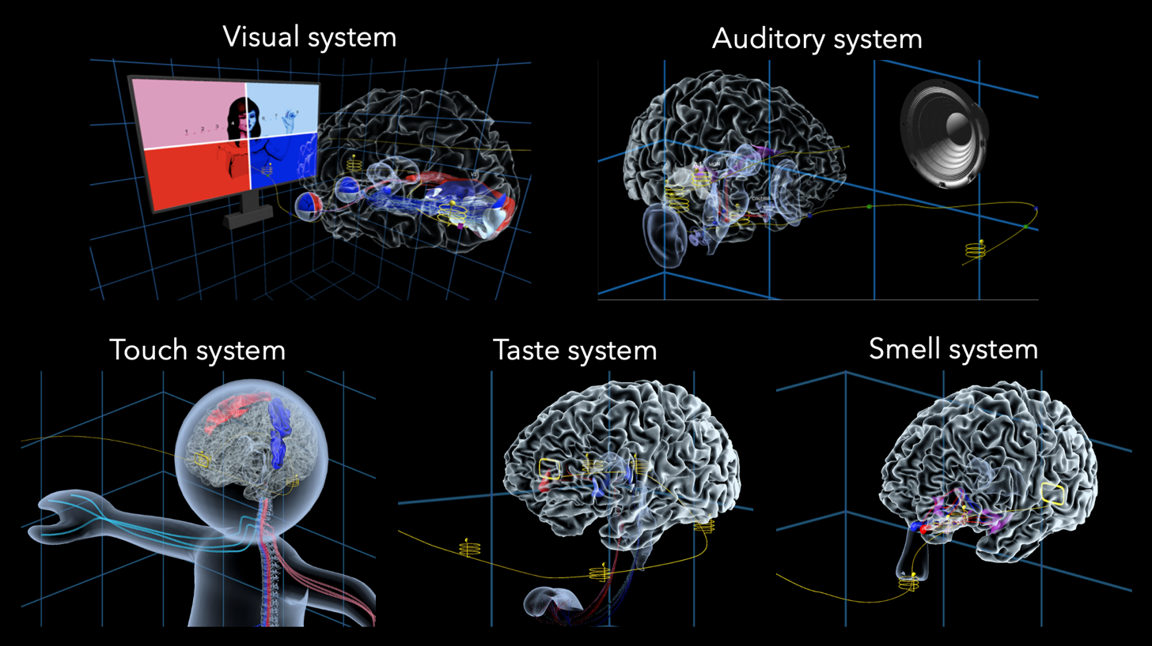

Preparation:
The day before a learning experience, plug in all headsets that will be used to make sure they are fully charged. Check to make sure all headsets are working and do any necessary troubleshooting. If the headsets haven’t been used for a while this there may be unexpected issues to work through and preparing the day before gives you time to fix them, while keeping any issues and fixes fresh in mind. This is also the time to check whether the batteries for the controllers are full enough and whether you should buy more in preparation. To preserve battery life, make sure batteries are removed from the controllers when not in use. It is a good idea to have a set of backup batteries you keep with your headsets and bring to the classroom or event space.
If the headsets will be used for a long period such as during multiple class periods or a science festival event, be sure to keep charging cables accessible and check whether you will have access to power during the event. Depending on how long the day will be and how many outlets you will have access to, you may want to plan to cycle through headsets so that some may charge while the others are in use. A safe assumption is that you can count on each headset holding charge with continuous use and no charging for about 2 hours. Different headsets may last longer or run out of energy faster. Newer models tend to last longer, but it is a good idea to check how long your specific headsets hold charge and how long it takes to charge them back up after they are depleted. With charging and potentially cycling through headsets most can last through an entire day’s worth of activities.
For first time Virtual Brain instructors or when preparing for a new lesson context, it is beneficial to run though setup and the different lessons to get an idea of how long your setup will take, determine how many lessons each student will have time for as well as which settings to use during the lessons.
Make sure to also bring plenty of hand sanitizer and cleaning wipes for large events. Clorox wipes work well and after wiping them down, the headsets dry quickly. Headsets should be wiped down at the beginning of a lesson or event, between students, and at the end of the day for good sanitary practice and to help maintain the headsets.
If you are able, prepare and bring a laptop or computer with the Virtual Brain desktop version downloaded. This is so students who are uncomfortable using VR, or would prefer another format, may still participate and engage with the lessons.

Setup Guidelines:
Different strategies can be used depending on the context of the learning. Specifically, two main contexts that the Virtual Brain might be used in is during a fixed lesson time or a science festival/fair. The fixed lesson time might provide you with more flexibility, time for set up, and the ability for students to experience multiple lessons. A science festival might have a more compact time slot and less flexibility, but is still a fun, immersive environment to complete a Virtual Brain lesson.

It is beneficial for the instructor(s) to set up the program for students beforehand. This includes opening up the app, setting up the lesson and checking that the appropriate settings are selected. This may mean arriving and setting the headsets up early if you can (depending on how many headset you will be using at once).

In settings with greater time restrictions, if there are multiple instructors or a teaching assistant it may be a good idea to have one instructor introduce the activity while the other prepares headsets and controllers. Otherwise, a single instructor can set the headsets up as they instruct individual students and pass them the headsets.

When the program is first opened, a blue menu with a list of lessons should appear:

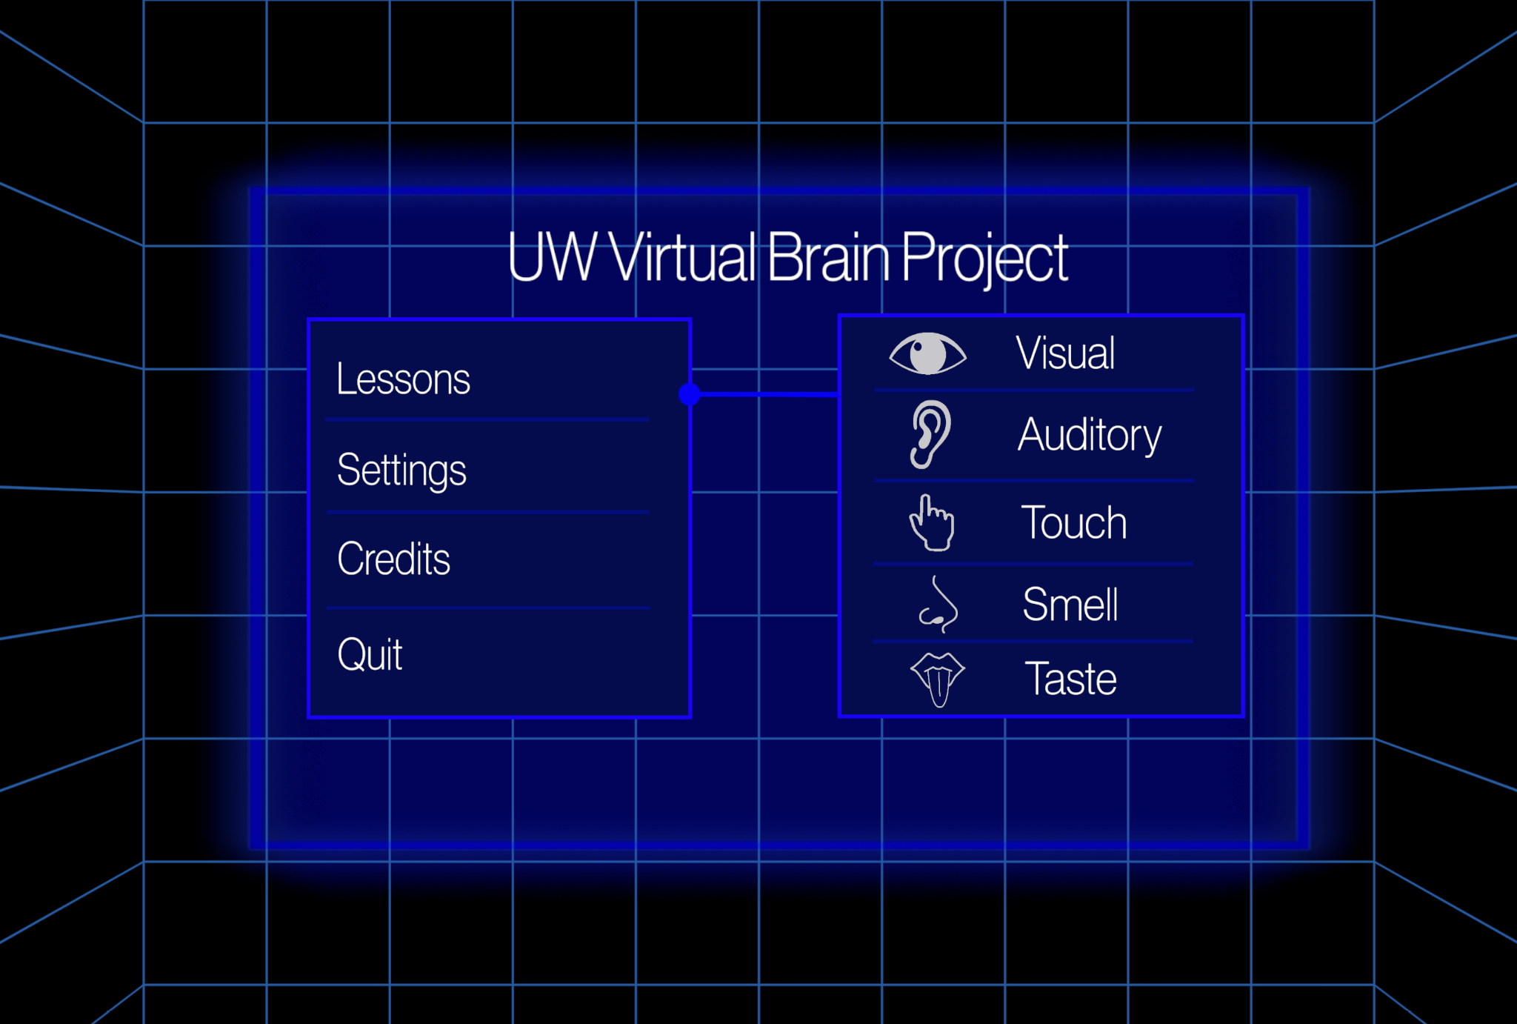

Check whether the station guards are on the correct settings for your purposes. The station guards can be turned on an off using a switch under the settings tab in the Virtual Brain menu:

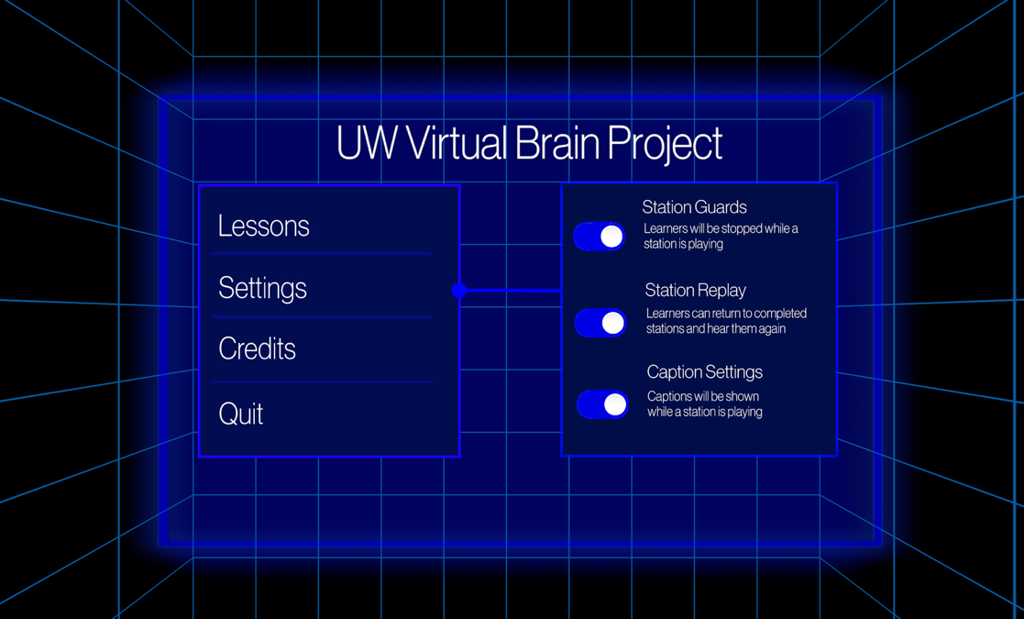

When there is less time available for lessons, turning the station guards off can help move through lessons faster. We recommend turning them off at large events such as science fests so that there is time for many students to engage with the Virtual Brain. The default setting is the station guards being on, so it is recommended to double check occasionally in the case that someone quits the program by accident.

Instructing Learners:
If you are giving Virtual Brian lessons in a context where everyone gathers at the beginning of the lesson time, it is helpful to explain the controls and any necessary strategies to move through the lessons for the whole group, ideally with a visual aid. Then when interacting with individual students and first giving them the headsets to use, remind them of the instructions and help clarify any confusion points while answering questions.

In a more fluid environment where students may come and go, such as a science fest, you may explain and demonstrate the controls to the student just before they put the headset on.

When explaining the headset and controls, first show students the headset and how it may be adjusted to fit properly. Demonstrate turning the wheel on the back of the headset to tighten and loosen the strap, and the Velcro on the top strap for extra support. Then set the headset to the side to show them the controllers.

For younger kids, it could be useful to set the program up for them and hold the headset in front of their eyes, rather than having them wear it. The headsets won’t fit very small kids, so holding the headsets for them will be necessary in these situations. It can also be a useful approach if a younger child is apprehensive, but still wants to try the headset. For young children you may also need to help move the controls on the joystick for them. At a science fest event it may be helpful to ask a parent or guardian at the event to help with this.
When orienting students to the controllers, turn partway so that your left and right aligns with the students’ and hold the controllers away from your body so that they can see the top of the controllers. Demonstrate how to hold the controllers (thumb should be on the top or the side button, with pointer finger curled around the front trigger of the joystick). There is a “right hand” and “left hand” controller, so make sure students have them in the correct hand. The buttons on the side of the controller should face each other when the two controllers are held in their correct hands side by side.

To instruct students on how to move through the lesson, point to the joystick on the top of the controller and push it forward. This is the main control they will need to know. You may also describe the “yellow track” that should appear by their feet that they will be moving along as they are carried through the lesson.

In certain lessons, students may be able to interact with the lesson materials by selecting things. Demonstrate how to “click” by pointing the controller at an item to select and then pulling the trigger on the front with your pointer finger to “click” on it just like a mouse. You may also describe that a yellow beam will extend out of their controller that they can use to point at what they would like to select (in cases where lessons involve clicking or if students are navigating the menu and going through lessons themselves). Students will be able to choose their dominant hand when first entering the lesson by pulling the controller trigger for that hand (or depending on time/age constraints you may do this for them, a display appears at the begging of the lesson instructing them on how to do this as well). Whichever hand they designate as their dominant hand will be the controller used to navigate through the lesson and select things. They may choose not to hold the other controller or if they would like or may hold the other controller and use it to read along with the narration during the lesson (the offhand controller displays text for accessibility).

Depending on whether students are navigating and selecting lessons on their own or not, you may also want to specify at this point what the “A” button on the top of the controller does. Pressing the “A” button will cause the student to exit the lesson and return to the Virtual Brain menu where they started. If you have tighter time constraints per student, you may want to instruct students not to press this button as if they leave the lesson, they will either have to start a lesson over or not finish that lesson. If students are navigating for themselves and there is flexibility, you may instruct them to press “A” when the lesson has finished to return to the menu and select their next lesson.

Once students have been oriented to the controls, let them put on the headset and adjust until comfortable (you may need to help young children with this). Offer to help if a student is struggling with adjusting the headset. If a student has hair that falls over their forehead, you may suggest they brush their hair to the side as sometimes this can interfere with the sensor in the headsets.

IMPORTANT: Some students may try to walk or move around once they have the headset on. Be sure to instruct them not to for their own safety and the safety of those around them. When they have the headsets on, they are unable to see their surroundings and may walk into or hit someone or something. Remind them that they move through the lesson and the space byt pressing the joystick forward.

For students who are uncomfortable using VR or would prefer another format there is a desktop version of the Virtual Brain available. Some students may also prefer to be seated while using the headsets in case of nausea or they get dizzy. If this is the case find a chair with enough space around it for them to sit and turn comfortably.

Navigating lessons:

Once you or the student has entered the lesson, the program will first ask the user which system they would like to explore: visual, auditory, touch, olfactory, or gustatory (pictured to the left). Make the selection by pointing the handheld controllers at the desired system and clicking the trigger.

Once in the lesson, the user will be asked whether they primarily use their left or right hand. This will indicate which of the two handheld controllers will be used to navigate the lesson. Make the selection by clicking the trigger using the desired hands controller.

Once the desired hand has been selected a popup screen will appear with instructions on how to use the controllers to navigate the lesson. To begin the lesson, students simply push the joystick forward to move through the screen. Occasionally, this screen can cause some confusion, so it may be helpful in certain settings to set everything up for a student up to this point and then move them through the instructions screen so they don’t see it.

Once the user is in the lesson, they may press the joystick on the controller forward to navigate along the track at the desired pace.

Resetting:

At the end of the lesson, pressing the “A” button on the controller will give the user the option to reset the program and return to the main screen, where they can choose another lesson if desired.

Troubleshooting:

Listed below are some potential issues with the program or the headset and their solutions.

If the headset’s vision is blurry: it is likely that the headset is not situated properly and should be adjusted to correct the display. The headset’s fit can be adjusted with the velcro on the top and the wheel on the back.

If students are unable to hear the narration check the volume on the headset and help them adjust until it is a comfortable volume. Sometimes the volume settings can be accidentally adjusted down when many people are handling the headsets to take them on and off.

If the lesson repeats itself: the lesson has ended. It can be a bit confusing if the user misses the statement specifying that they have completed the lesson. You may exit the lesson using the “A” button on the controller (following the instructions under the prior ‘Resetting’ section).

If students notice they are not inline with the track, hold down the flat meta menu button on the to reset the headset’s spatial orientation.

It is possible that students will mistake the initial instruction screen as ‘what controls to push right now’. To limit this issue, before giving the student the headset, communicate with them that they are about to see an instruction screen and how to skip past it when they are ready to begin (select their dominant hand and then simply push the joystick forward and move through the instruction screen). Alternatively, set up the lesson for each student (asking for their preferred hand) and pass through this screen so they don’t encounter it. This way all they have to do is push the joystick forward. In settings with limited time or where you are managing many new students of various ages such as at a science fest, this is an effective strategy.

As previously mentioned in the ‘Set Up Guidelines’ section, making sure station guards are on or off in the settings page can impact the experience.
Further Resources and Support:

The UW Virtual Brain Project website (https://schlosslab.discovery.wisc.edu/portfolio/uw-virtual-brai n-project/) provides a demo of the visual and auditory pathways, academic research on the topic, and a form to download the program.

